

Operations Assistant
Hours: 28-35 hours per week. This post is available on a full-time, part-time, or job share basis

Contract: 12-month contract from start date

Salary: £28,000 per annum

Base: Shared Care Scotland offices, Dunfermline. Hybrid working applies and a copy of our Hybrid (Remote) Working Policy is available on request.

Responsible to: Operations Coordinator
Job purpose:
Shared Care Scotland is a small team with big ambition: we aim to be the lead organisation in Scotland on all aspects of short breaks policy and practice. The Operations Assistant has an important organisation-wide role in providing efficient, accurate and responsive administrative support that helps colleagues, Board members, partners and enquirers work effectively.

Working closely with the Operations Coordinator and the Head of Finance and Operations, the role will support the smooth day-to-day running of the organisation by maintaining effective office systems, coordinating core administrative processes and providing practical support to colleagues across all areas of Shared Care Scotland’s work, including Board of Directors meetings.

In addition, the Operations Assistant will coordinate our dedicated short breaks enquiry service and provide administrative support for events, meetings, projects and other organisational priorities as required.

Key result areas:
The Operations Assistant will:
- Provide responsive administrative support across Shared Care Scotland, helping colleagues coordinate meetings, maintain records, follow agreed processes and deliver organisational priorities effectively.

- Oversee the smooth running of the organisation’s office systems, administrative procedures and shared records, working with the Operations Coordinator to ensure these are efficient, up to date, compliant and easy for colleagues to use.

- Manage our short breaks Enquiry Service, responding to carers, professionals and other stakeholders in a timely manner and maintaining detailed information about short breaks opportunities and other, related services in Scotland.

- Organise Board of Directors meetings, prepare and circulate papers, take accurate minutes, track actions and assist the Operations Coordinator and Head of Finance and Operations in arranging the Annual General Meeting.
- Support the Operations Coordinator in managing Shared Care Scotland’s online Directory of Short Breaks Services.

Key tasks and responsibilities:
Communications and systems
- Organise and keep under review administrative systems and procedures, identifying opportunities to make improvements and increase organisational efficiency.
- Deliver our Enquiry Service by responding to short break enquiries effectively and efficiently, maintaining target response times.
- Manage the Online Short Breaks Directory by identifying and registering new providers on the service and maintaining existing provider records, ensuring that these are accurate and up to date.
- Act as the first point of contact for our Managed IT providers to support the quick resolution of issues and queries.
- Record and track enquiries accurately and provide regular reports to the Operations Coordinator.

Office management
- Maintain supplies of office resources by tracking stock and placing orders as necessary.
- Ensure a cost-efficient approach to managing supplies and resources by investigating and recommending economical choices.
- Identify and arrange office maintenance and repairs, acting as the first point of contact with Fife Council concerning the office lease at Dunfermline Business Centre.
- Have responsibility for maintaining and updating our asset register.
- Process invoices and expenses, liaising with the Bookkeeper to ensure that these are paid in a timely manner.
- Work with the Operations Coordinator to ensure that staff are supported with up to date and correctly configured IT equipment and software.

Board of Trustees
- Arrange the organisation’s Board meetings, including dates, venues and catering.
- Act as note taker for the Board, producing detailed, reliable minutes of meetings.
- Maintain a well organised record of Board paperwork and ensure timely communications with Board members.
- Support the Operations team in organising and delivering Shared Care Scotland’s Annual General Meeting.
General Tasks
- Assist colleagues with the administration of conferences, events and meetings, including Learning Exchange events as required.
- Represent Shared Carer Scotland at external meetings and events, promoting our work and services.
This job description is indicative of the nature and level of responsibilities associated with this job. It is not exhaustive, and the job holder may be required to undertake other duties and responsibilities commensurate with the grade.

Key contacts:
Internal
- Shared Care Scotland colleagues
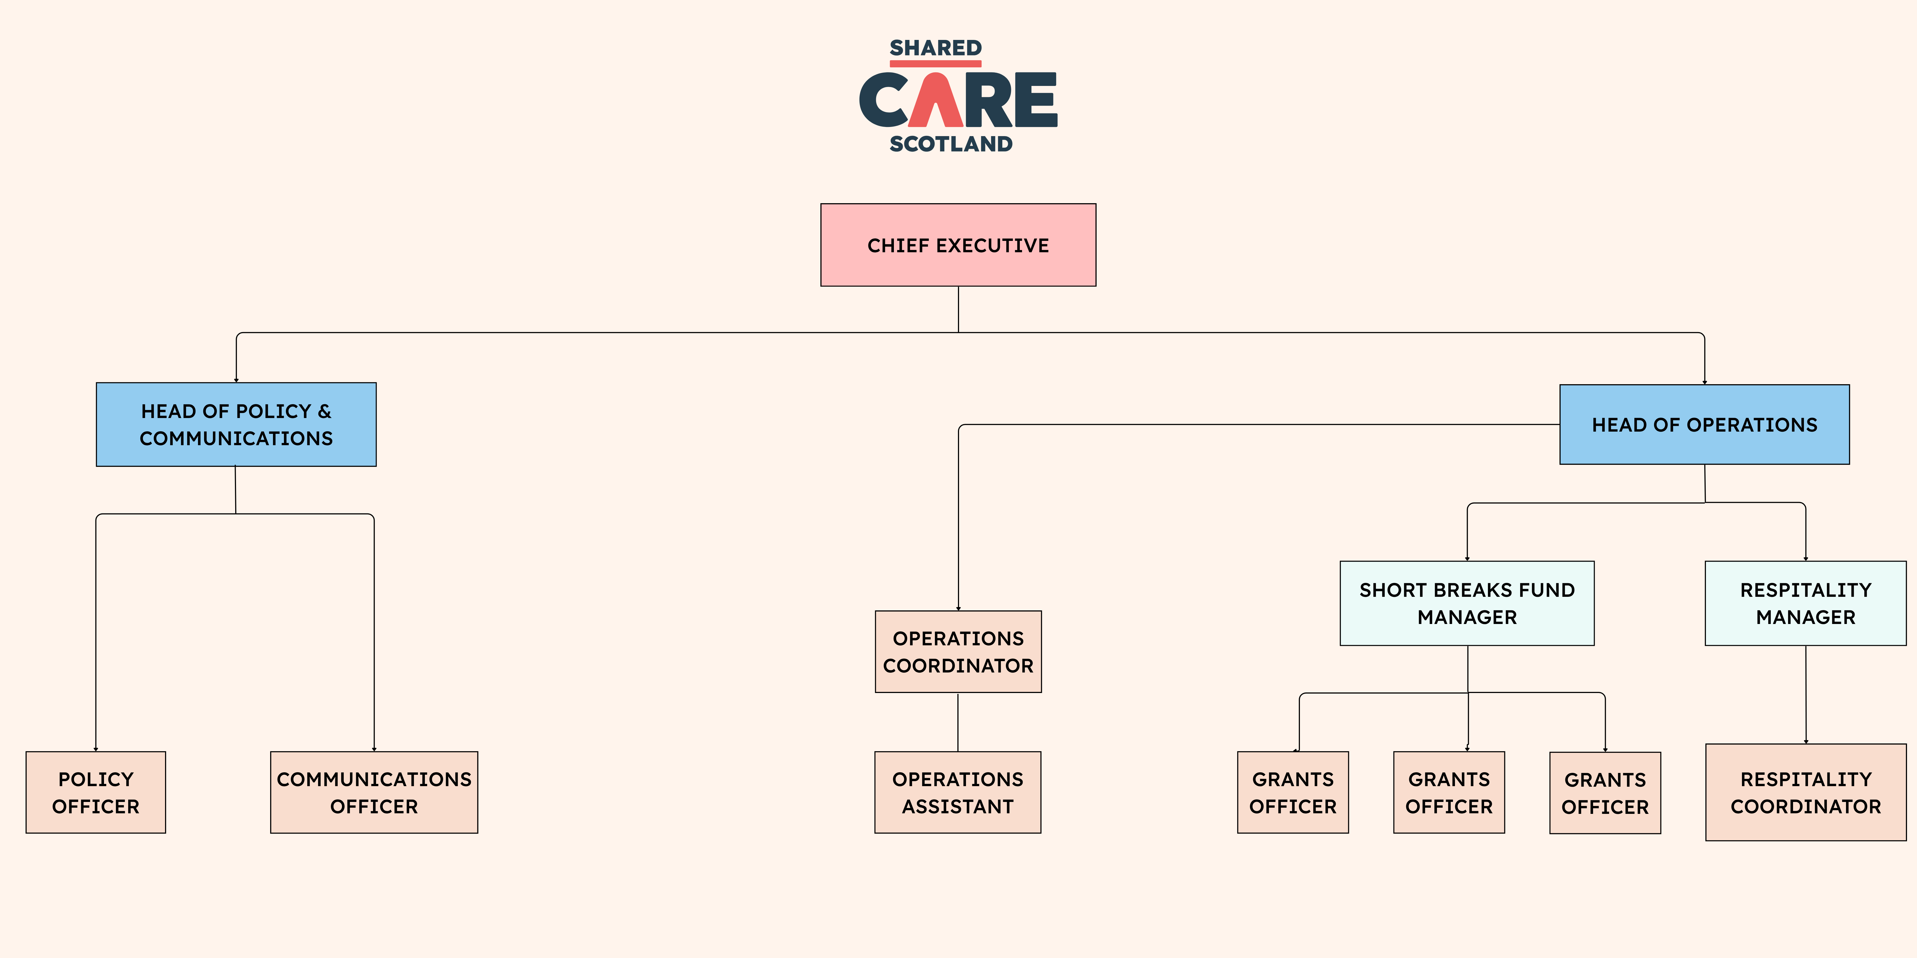
External
• Board of Trustees
• Enquirers (members of the public, sector professionals and elected officials)
• Short break providers
• Shared Care Scotland members
• IT, web, finance and office management contacts
• Fife Council
• Carers’ centres staff
• Other stakeholder organisations

Person specification:
Essential attributes and skills | Essential | Desirable
Proven experience of working in an administration role within a busy office with a strong customer service ethos and high level of professional integrity | 
Ability to use own initiative, prioritise and organise own workload, and manage conflicting priorities while meeting deadlines
An aptitude for helping people and working effectively within and between teams with a flexible approach
A positive outlook, strong work ethic and good problem-solving skills
Excellent written and verbal communication skills with high standards of accuracy and attention to detail
Demonstrable experience of developing and implementing office systems to improve efficiency and effectiveness
Strong working knowledge of Microsoft Office packages and willingness to learn new applications as required
Commitment to, and passion for, the purpose, aims and values of Shared Care Scotland
Flexibility in working hours when necessary
Experience and knowledge of the third sector/voluntary sector
Experience of using and administration of accounting software
Experience of attending Board / senior management meetings and the ability to prepare and issue agendas and take minutes of meetings

